**…JAVASCRIPT…**

**Javascript:**

* It is used to add functionality and behaviour into web app.
* It is loosly typed language.
* It is an Loosely typed language.
* It is interpreted language.
* Javascript is object base language.
* In JS window is Global Object.
* Javascript is asynchronous in nature.
* In JS all the process works on a single thread.

**There are Two ways to Use Javascript:**

1. Internal Javascript: In html file we use Script tag and we write Javascript code.
2. External Javascript: In this we create separate JS file and that JS file will import in html file by using script tag.

**How to display output in JavaScript:**

1. Document.write(): It will display output on webpage.
2. Window.alert(): It will generate one pop-up window to display output & It execute
3. Console.log(): It will display output in browser console or terminal(used for testing purpose)
4. DOM(Document Object Model):

**Que:**

Why Javascript is called as Loosely Typed Language?

What is Difference between let, var and const keyword?

Primitive & Non-Primitive Datatype Difference with example?

Looping & Conditional Statements?

Difference Between Modulus and Division?

What is Difference between == & ===

5===5 //true

5===’5’ //false

* When we create a variable in JavaScript, we cannot determine what type of data it contain until and unless initialize it.
* let, var and Const are three variables which are used for to Initilize the value to the variable.
* == //It checks value only if both are same then it returns true result.
* === //It will check both Value as well as Its Datatype, if both are same then it returns true

**How to create a variable in JS:**

**Syntax:**

let variable_Name; // Variable declaration

variable_Name=value; //Variable Initilization

let variable_Name=value; //Defining a variable

There are mainly two datatypes:

1. Primitive datatype: number,string,Boolean,undefine,null;
2. Non-Primitive datatype: array,object;

**Null datatype:** To prevent to store a garbage value in variable for that purpose we use Null Datatype.

**Operators in Javascript**:

Exponentiation(**) : It return power of any number.

e.g: 5**3

**12/04/2024**

**Function:**

* It is a block of code which will used for particular task or operation.
* Function will be execute only when we call it.
* It can be reuse multiple time.

**Syntax:** function functionName()

{

Code

}

**Types:**

1. In-built Functions:
2. User-defined functions:

**Anonymous Function:** A function with no name is called as “Anonymous function”.

**Arrow Function:** Function with no name & No function keyword.

**Optional Parameterized Function():** In this parameter will optional not mandatory to pass value to itIt always write at last.

**Rest Parameterized Function:** When we don’t know how many parameters are required in that case we use it.Here we use spread Operator.

**Array:**

It is used to store multiple values with same datatype.

In array values store on Index basis.

Array index always start from 0 index.

To access data outside array for that we write array[index_number]

Array is Collection of similar type of data.

Array Stores its elements Sequentially,Linearly & Contigously.

Array index is always start with 0 & Ends with size-1.

Array is denoted by []: Square bracket.

**How to use External Javascript:**

1. By using DOM how to set value.
2. By using DOM how to get value.
3. By using DOM how to apply style rule.

Push(): Add values at last index of Array.

Pop(): Remove values from last index of an array.

Unshift(): Add values at Starting index of an array.

Shift(): Remove values at starting index of array.

**Array methods:**

1. For of
2. For in

**Object:**

It store multiple values with different datatype.

In object data store in key and value pairs format.

Denoted by: {}

We can access object data outside by writing object.keyname

**Data stored in {} format**: It stores data in form of objects.

**How to insert Date & time in Webpage:**

If you want to get date and time in javascript for that first we have to create object of date class.

Syntax:

Let dataObj=new Date();

Date class returns data from browser.

**How to create digital clock:**

Task: Write & Implement logic for calculator:

Task: Set selected cell background color:

Task:Design digital clock:

Task:Display current month and day by using Date class object:

**String & Its method:**

It is a collection of character.

In string every letter has index value and Its starts from index start from 0.

In string white space is also considered as string.

**In JavaScript we have 3 methods which return index of searching string:**

1. **indexOf (searching-string, start-index):**

* It return index of first occurrences of searching string.
* It search string from left to right.
* If searching string is not found then it return -1 as a result.

1. **lastIndexOf (searching-string, start-index):**

* It return index of first occurrences of searching string.
* It search string from left to right.
* If searching string is not found then it return -1 as a result.

1. **search(searching-string):**

* It return index of first occurrences of searching string.
* It search string from left to right.
* If searching string is not found then it return -1 as a result & It is faster than indexOf() method.

**There are 3 Methods which are return part of string by passing index number:**

1. **Slice(startIndex,endIndex):**

It will return part of string.

If we write +ve index then it will reach from left to right.

If we write -ve index then it will reach from right to left.

1. **substring(startIndex,endIndex):**

It will return part of string.

If we write +ve index then it will reach from left to right.

1. **subStr(startIndex,total-number-of-character):**

It will return part of string.

If we write +ve index then it will reach from left to right.

1. **Replace:**
2. **Trim() :** It remove unwanted space of both side string.

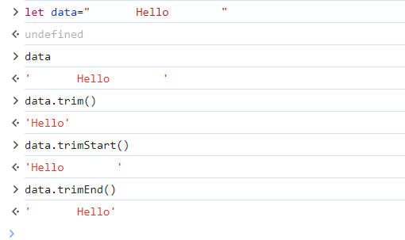

**\*callback() Method:**

Passing one function as an argument inside another function is called as “callback() method”.

When we write one function as an argument inside another function we do not use parenthesis.

**2 Methods:**

1. **setTimeOut(callback function,duration):**

It calls another method only once after a perticular time interval

1. **setTimeInterval(callback function,duration)**

It calls another method multipleafter perticular time interval.

**In 2009 (ECMA script-5 or ES-5**); European computer manufacturers Association.

**In 2015 (ECMA script-6 or ES-6);**

**Que. How will convert Object type of data into JSON?**

In many programming languages, you can convert an object type of data into JSON format using built-in functions.

**Syntax:**

Let obj={name=”Pranu” age:60,city:”Pune”};

Let json=JSON.stringify(obj);

Console.log(json);

**Que.Difference between toString() & Join() method:**

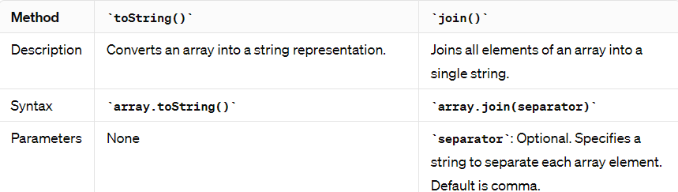

**Notes:**

* We already know what type of data stored in code is called: Strict Type Language
* C & CPP are the Compiled Language, and It is Loosely Coupled Language.